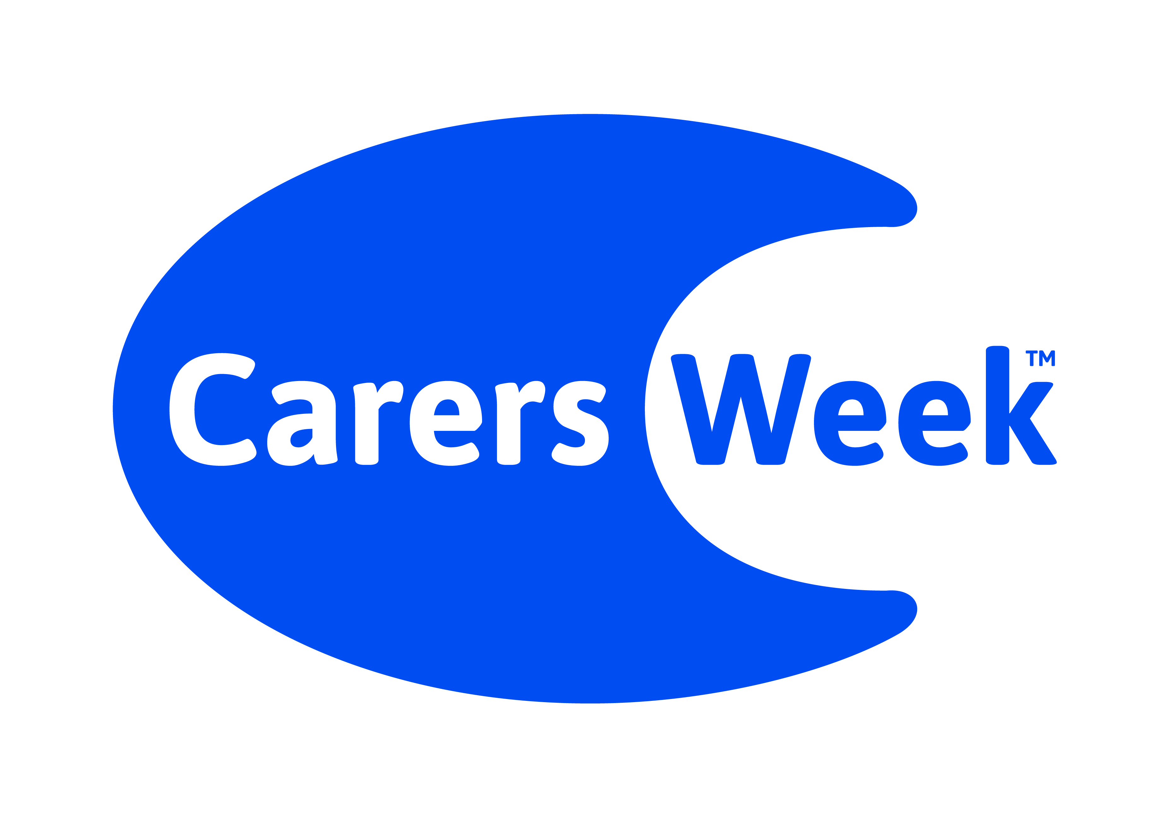
Carers’ Information & Celebration Drop-In Event
Friday 15th June
10:00am to 3:00pm
Clover & Wolf (formerly The Mile),
Brigham Place, South Shields NE33 2DL

Celebrate Carers Week and find out how you can stay healthy and connected from a wide range of local groups and organisations.
The day includes:
Information stalls
Therapies
Healthy food demo and tasters
Health & wellbeing advice
Entertainment
Refreshments

